OKP1 -

Functionality
Use the period lock to lock plan and actual business transactions for a combination of controlling area, fiscal year, and version to prevent further postings.

Scenario
This work instruction illustrates locking the actual postings for the period of June in controlling.

Requirements
All postings in OCM for the period have been executed.

Menu Path | Accounting → Controlling → Cost Center Accounting → Environment → Period Lock → OKP1 - Change
Transaction Code | OKP1

1. Double Click on OKP1 - Change

Change period lock : Initial Screen

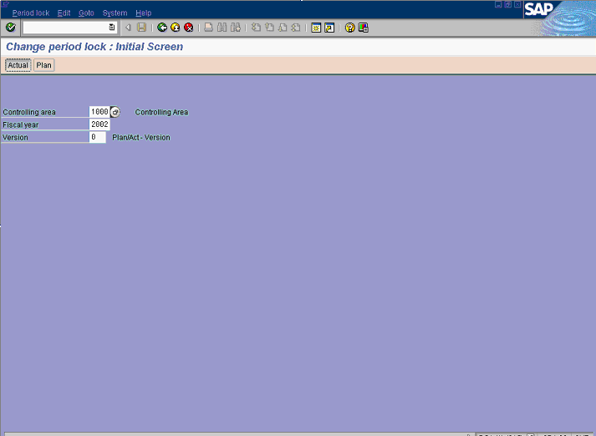

2. Update the following fields:

Field Name | Field Description | Values
Controlling Area | Organizational unit in SAP Controlling. SABIC uses only: | Example: 1000
Fiscal Year | Relevant fiscal year | Example: 2002
Version | Controlling area related collection of year-dependent indicators for planning data. | Example: 0

3. Click Actual Button .

Change actual period lock : Edit

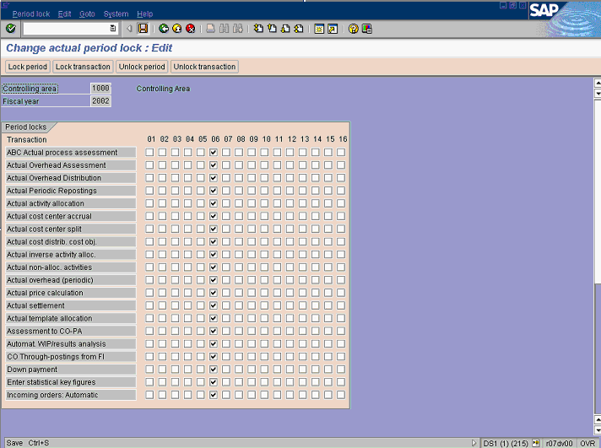
4. Click the period you want to lock, for instance: 06 .
5. Click Lock period Button .
6. Click the Save button.
Note: It is also possible to lock in dependant transactions by activating the revenant radio button in the list.

